India’s Hidden Language
Posted Dec 13,2010
Abamo Degio learned Koro when she married a native speaker.
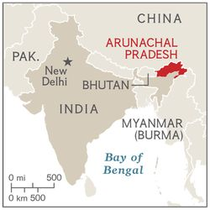Imagine a spoken language not shared by everyone in the same family—one that sounds as foreign to people in the next village over as Japanese does to most English speakers. That’s what U.S. linguists K. David Harrison and Gregory Anderson found in India’s remote northeastern state of Arunachal Pradesh. They traveled there in 2008 to document two obscure regional languages. They ended up detecting a third. Locals had assumed that the 800 or so speakers of this tongue, Koro, were using a dialect. But the linguists—part of National Geographic’s Enduring Voices, a project studying endangered tongues— have confirmed that it’s a distinct new language. Its quiet presence mirrors that of the culture sharing its name, concealed for centuries within the dominant Aka-Miji society. Linguists estimate the world loses one of its 7,000 languages every 14 days. To help keep Koro alive, Enduring Voices is compiling a sound archive and an online dictionary—a sure way to get the word out. —Hannah Bloch
A Koro Phrase Book
Koro is a Tibeto-Burman tongue. Short, melodic syllables help distinguish it from nearby languages.
Nu kapla echuyi?
How are you?
Ne kapla echo.
I am well.
Kaple’e.
Thank you.
Nu hagona?
Where are you?
Eme hapuna inyingonde?
Where are we going?
Ti igina?
What is this?
Ne li murulim lele rangi.
I gave the pig to the man.
Lele nemi chiba.
The pig bit me.

Photo: Chris Rainier. NGM Maps
Posted by National Geographic Staff | Comments (1)
Found at http://blogs.ngm.com/blog_central/2010/12/indias-hidden-language-.html

