Name ___________________________ Due Date __1/12/2018____________

AP Human Geography
Agriculture Guided Study Questions
Section A (Chapter 12) – Agricultural Development
1. Where were the early agricultural hearths? Shade the map to show these hearths.

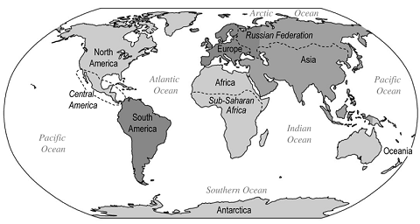
2. How did the first agricultural revolution lead to specialization?

3. How did the Columbian Exchange result in the globalization of domesticate plants and animals?

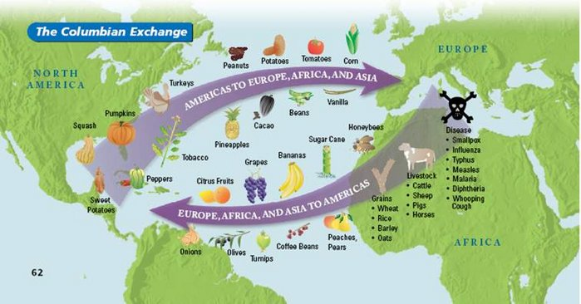
4. Explain the connection between physical geography and agricultural practices.

5. How does population alter the physical landscape to increase food production?

6. Define the following agricultural practices. (draw an illustration)

- Terracing

Pros –

Cons –

- Irrigation

Pros –

Cons –

- Draining Wetlands

Pros –

Cons –

- Slash and burn

Pros –

Cons –

- What are the environmental challenges facing farmers as they move from subsistence farming to commercial farming?

7. Second Agricultural Revolution

- What were the English Enclosure Acts?

Pros –

Cons –

- What are some of the technological advances of the second agriculture revolution? (see chart)

- How did these advances increase production? (see same chart)

8. What impact did these advances have on:
a. diet?

b. length of life?

c. population growth?

d. growth of cities?

9. What is the Green Revolution (third agricultural revolution)?

10. Define and describe the roll of the following terms in the Green Revolution:

- Hybrids

- GMOs

- Machinery

11. What impact did high yield seeds have on agricultural practices?

12. What are the positive consequences of the Green Revolution?

13. What are the negative consequences of the Green Revolution?

14. What has been the impact of the Green Revolution on Gender Roles?

15. While the Green Revolution has been successful in Latin America and Asia, it hasn’t been successful in Africa. Why not?

Name ___________________________ Due Date __1/19/2018____________

Section B (Chapter 13) – Agricultural Regions
16. Label the major agricultural regions and color in their bioclimatic zones. Provide a color code key below.

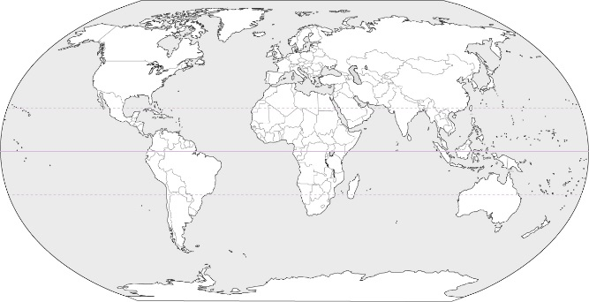

Key of bioclimatic zones:
Drylands
Tropical
Sub-Tropical
Cold Mid-Latitude
Warm Mid-Latitude
Polar

17. How do spatial variations in temperature and rainfall (i.e. climate) determine agricultural production?

18. Define and provide an example for the following types of agriculture. How are they influenced by economic factors?
- Subsistence Farming

- Commercial Farming

19. Define and provide an example for each of the following forms of subsistence farming:

- Pastoral Nomadism

- Shifting Cultivation with slash and burn

20. Define and provide an example for each of the following forms of commercial farming:

- Plantation farming

- Mixed Crop/Livestock farming

- Grain farming

- Commercial Gardening (include definition of market gardening and truck farming)

- Dairy farming (include the definition of the milk shed)

- Mediterranean agriculture (include the definition of transhumance)

- Livestock ranching

21. How do economic factors influence the following?
a. intensive land use

b. extensive land use

22. What are intensive farming practices? Provide an example.

23. What are extensive farming practices? Provide an example.

24. What is the impact of large scale commercial agriculture (Agribusiness)? What impact does it have on small scale farms? Include the definition of suitcase farms.

25. What are commodity chains? What are the benefits?

26. How has large scale agribusiness connected production and consumption?

27. What technological improvements change the economies of scale in the agriculture sector?

28. Explain the interdependence of regions of food production and consumption.

29. How are agricultural products from low-latitude regions part of the global food chain?

30. How do the following affect the patterns of global food distribution?

- political systems (colonialism and neocolonialism)

- fair trade

b. government subsidies and infrastructure

c. THINK 1: what patterns of world trade do you see? Who benefits the most from a global food market? Why?

Name ___________________________ Due Date __1/26/2018____________

Section C (Chapter 14) - Settlement Patterns and Rural Land Use
31. Draw the following rural settlement patterns.
a. clustered | b. linear
c. dispersed

32. Why is von Thünen’s model of land use important to rural land use practices?

33. Complete the von Thunen model analysis (Model 1 of the models packet).
34. What are some of the environmental impacts of large scale commercial farming? Include irrigation, desertification, deforestation, wetland destruction, and conservation efforts.

Section D (still Chapter 14) – Changes in food Production
35.Define the following modern agricultural innovations.
a. biotechnology

b. genetically modified organisms (GMOs)

c. organic farming

d. aquaculture

36. How have the above agricultural innovations created conflict and controversy regarding environmental, cultural and health impacts?

37. How are the following issues related to agriculture?

- extensive fertilizer and pesticide use

- river and aquifer depletion

- loss of biodiversity

d. soil degradation

e. animal waste

38. THINK 2: are the current methods of farming sustainable? Why or why not?

39. How does food choice impact the patterns of food production and consumption?

40. How do the following influence food choices?
a. organic farming

b. valued-added specialty crops (look this up!)

c. fair trade

d. local food production and transportation

41. How has technology impacted gender roles in food production and preparation?

Model 1: VonThünen
Person who developed the model/theory: (short bio)

Premise: (What is the model supposed to explain?)

Function: (How or when is the model/theory used?)

Illustration: (Draw the model or symbols to demonstrate the key ideas)

Strengths of the model/theory:

Weaknesses of the model/theory:

Describe the effectiveness in the field (past and present)

