What's in a Surname?
Posted Jan 19,2011
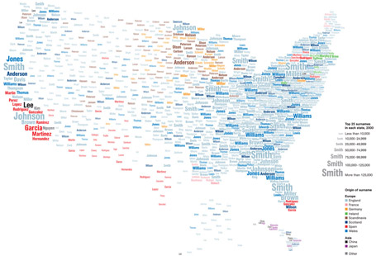
Map: Mina Liu; Oliver Uberti, NGM Staff. Source: James Cheshire, Paul Longley, and Pablo Mateos, University College London.
To examine the map more closely, click here or on the image above.
What's in a Surname? A new view of the United States based on the distribution of common last names shows centuries of history and echoes some of America's great immigration sagas. To compile this data, geographers at University College London used phone directories to find the predominant surnames in each state. Software then identified the probable provenances of the 181 names that emerged.
Many of these names came from Great Britain, reflecting the long head start the British had over many other settlers. The low diversity of names in parts of the British Isles also had an impact. Williams, for example, was a common name among Welsh immigrants—and is still among the top names in many American states.
But that's not the only factor. Slaves often took their owners' names, so about one in five Americans now named Smith are African American. In addition, many newcomers' names were anglicized to ease assimilation. The map's scale matters too. "If we did a map of New York like this," says project member James Cheshire, "the diversity would be phenomenal"—a testament to that city's role as
a once-and-present gateway to America. —A. R. Williams
Posted by National Geographic Staff | Comments (20)

Found at http://blogs.ngm.com/blog_central/2011/01/whats-in-a-surname.html

