About Microfinance

Microfinance — also called microcredit, microlending, or microloans
Microfinance is a highly successful economic development tool to alleviate global poverty. The term "microfinance" refers to the practice of providing financial services to hardworking people with no collateral or credit history.
Microfinance services can include:
- Small loans or group loans
- Microsavings
- Microinsurance

Microfinance stimulates economically depressed areas
Microfinance loans foster small-scale entrepreneurship and act as a hand up in situations where a handout is not helpful. Small loans give impoverished individuals the working capital they need to start or grow a business. With one in five people worldwide surviving on less than $1.25 a day, the need is great.
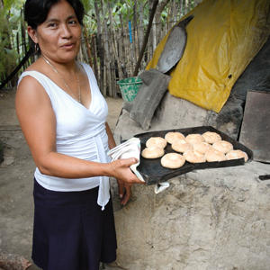Since receiving her loan, "everything is different," says Rafaelita Garcia, a single mother of two in Mexico. "I can buy flour, oil, sugar, eggs, cheese, yeast, and everything I need to bake my bread ... we should give ourselves a better life."
Current microfinance shortage:
- Only 3% of the global need is being met
- 16 million people currently access microfinance
- 500 million more people could potentially benefit

Microfinance benefits ripple out to families and communities
As a business generate profits, small loan recipients build assets, save money, and are able to provide for their families. If the business expands to hire additional employees, then the entire community gets an economic development boost. Once repaid and recycled, microfinance loans can help family after family lift themselves out of poverty.
Microfinance leads to:
- More education
- Better health
- Improved diet and nutrition
- Resilience in the face of disasters

Microfinance ultimately breaks the cycle of poverty
Microfinance gives hardworking people the opportunity to move from dependence on aid to financial self-sustainability — empowering them to change their own lives and the lives of their children.

