Name ____________________________ Period ________ Due Date _12/01/2017_____________

AP Human Geography
Political Organization of Space
Unit 4
Section A (Chapter 9)

1. Define the following terms and given an example for each term.

a. nation

b. state

c. nation-state

d. stateless nation

e. multinational state

f. multistate nation

g. autonomous region

h. sovereignty

i. nationalism

2. Explain the process of historical European state building.

3. Define the following and provide an example for each.

Centripetal force:

Centrifugal force:

4. Define colonialism. Give two examples of countries and colonies.

5. Define imperialism. Give two examples of historic empires.

6. Explain how colonialism and imperialism lead to the spread of nationalism.

7. Explain how colonialism, imperialism, and nationalism influenced the modern political map.

8. What are independence movements?

9. Identify two Cold War independence movements and explain how they changed the world’s balance of power.
a.

b.

10. How did the fall of the Soviet Union (USSR) change the modern political map and shift the balance of power?

Name ____________________________ Period ________ Due Date _12/08/2017____________

Section B (Chapter 10)

11. Complete the Heartland Theory analysis sheet. (Model 1 models packet).
12. Discuss how the Heartland Theory is used to explain and analyze political power and control over people, land and natural resources.

13. Complete a Rimland Theory analysis sheet. (Model 2 models packet).
14. Discuss how the Rimland Theory is used to explain and analyze political power and control over people, land and natural resources.

15. Complete an Organic Theory of the State analysis sheet. (Model 3 models packet).
16. Discuss how the Organic Theory if the State is used to explain and analyze political power and control over people, land and natural resources.

17. Define territoriality.

18. Discuss how territoriality connects people, culture, economics and land.

19. Define the following types of boundaries.
a. defined

b. delimited

c. demarcated

d. administered

e. natural

f. geometric boundary

g. cultural boundary

20. What is the purpose of international boundaries?

21. Explain the following types of boundary disputes and provide examples:
- Definitional

- Locational

- Operational

- Allocational

22. How do boundaries influence identity?

23. How do boundaries promote or prevent international interactions, exchanges and conflicts?

24. How do boundaries promote or prevent internal interactions, exchanges and conflicts?

25. What is the Law of the Sea (UNCLOS)? What is its purpose?

26. Complete an analysis sheet for Mahan’s Sea Power Theory. (Model 4models packet).
27. Define and explain how each of the following influence the results of elections at various scales.
a. voting districts

b. redistricting

c. gerrymandering

Complete the following table:

Types of Gerrymandering
Type | Definition
Cracking

Packing

Stacking

Hijacking

Kidnapping

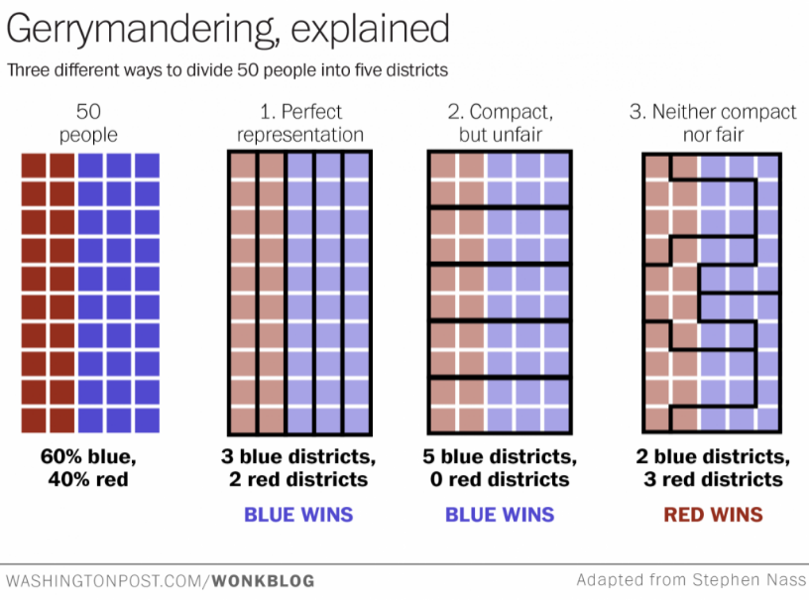
28. What happened when political boundaries do not align with patterns of language, religion, ethnicity, nationality, and economy (include a definition of shatterbelt)

29. Compare and contrast unitary states (centralized government) with federal states.

30. What are political subdivisions (local divisions)?

31. How do the powers of political subdivisions differ according to the form of governance?
[centralized states vs federal states].

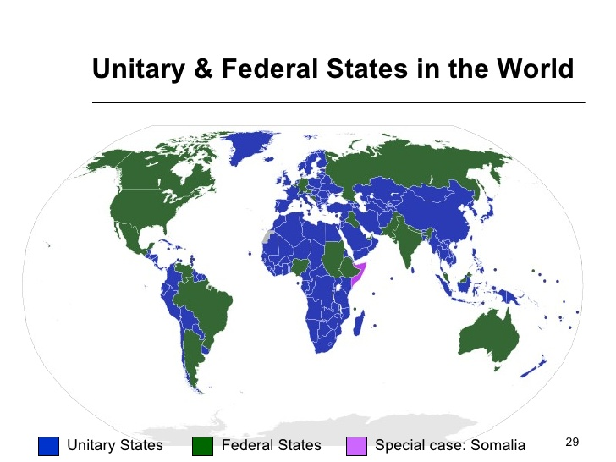
32. Define morphology and explain its influence on a state.

33. Define, draw and name a country for each of the following types of state morphology.
compact | elongated
perforated

prorupted | fragmented
34. Explain how state morphology influences economic, political and social structures.

35. Identify and explain three subnational political units that local and metropolitan forms of government use to exercise control.
a.

b.

c.

Name ____________________________ Period ________ Due Date _12/15/2017______________

Section C (Chapter 11)

36. Explain how the cultural, political, economic, and technological elements of globalization challenge state sovereignty.

37.Define supranationalism. Provide examples of supranational organizations.

38. Identify and explain how the following may contribute to the rise of supranationalism.
a. economies of scale

b. trade agreements

c. military alliances

d. transnational environmental issues

39. How do the following organizations meet the definition of supranationalism.
a. United Nations (UN)

b. North Atlantic Treaty Organization (NATO)

c. European Union (EU)

d. Association of South East Asian Nations (ASEAN)

e. North American Free Trade Agreement (NAFTA)

40. Define devolution.

41. How do the following forces lead to the devolution of states?
a. physical geography

b. ethnic separatism

c. terrorism

d. economic and social problems

e. irredentism

42. Define the following terms.
a. autonomous region

b. subnational political-territorial unit

c. Balkanization

43. Identify two examples for each type fragmentation listed below and explain the consequences of the fragmentation.

Autonomous region

Subnational political-territorial unit

Balkanization

44. How have advances in technology facilitated the following?
a. devolution

b. supranationalism

c. democratization

45. Identify 2 political, 2 economic and 2 cultural dimensions that can be centrifugal forces at a national scale.
a. Political

b. economic

c. cultural

46. Identify 2 political, 2 economic and 2 cultural dimensions that can be centrifugal forces at a national scale.
a. Political

b. economic

c. cultural

Model 1: Heartland Theory

Person who developed the model/theory: (short bio)

Premise: (What is the model supposed to explain?)

Function: (How or when is the model/theory used?)

Illustration: (Draw the model or symbols to demonstrate the key ideas)

Strengths of the model/theory:

Weaknesses of the model/theory:

Model 2: Rimland Theory

Person who developed the model/theory: (short bio)

Premise: (What is the model supposed to explain?)

Function: (How or when is the model/theory used?)

Illustration: (Draw the model or symbols to demonstrate the key ideas)

Strengths of the model/theory:

Weaknesses of the model/theory:

Model 3: Organic Theory of the State

Person who developed the model/theory: (short bio)

Premise: (What is the model supposed to explain?)

Function: (How or when is the model/theory used?)

Illustration: (Draw the model or symbols to demonstrate the key ideas)

Strengths of the model/theory:

Weaknesses of the model/theory:

Model 4: Mahan’s Sea Power Theory

Person who developed the model/theory: (short bio)

Premise: (What is the model supposed to explain?)

Function: (How or when is the model/theory used?)

Illustration: (Draw the model or symbols to demonstrate the key ideas)

Strengths of the model/theory:

Weaknesses of the model/theory:

