Name _____________________________ Period ________ Due Date _2/14 and 2/15__

AP Human Geography
Industrialization and Economic Development

Section A (Chapter 15 – Industrialization and Economic Structure)

- Where did the Industrial Revolution begin, and where did it diffuse?

[ Watch http://documentaryheaven.com/why-industrial-revolution-happened-here/ and do GVQs.
- List some technological advances arising from the Industrial Revolution

- Describe the impact of the Industrial Revolution on the following:
- agriculture

- population

- pollution

- public health

4. How did the Industrial Revolution lead to a rise in colonialism and imperialism?

- What is Fordism? What impact did it have on manufacturing?

Define the following:
- assembly line

- substitution principle

- post-Fordism

6. Define the following economic sectors.
a. primary

b. secondary

c. tertiary

d. quaternary

e. quinary

- Changing economic sectors
- What happens to the primary sector when a country industrializes? Explain your answer

- What is the multiplier effect? Give an example

- What happens when the multiplier effect works in reverse?

- What happens when MDCs de-industrialize?

Complete Weber’s Least Cost Model(#1 models sheet)pages 254-255
- Define and provide an example of a:
- bulk reducing industry

- bulk gaining industry

- What role does energy play in the history of manufacturing?

- Explain and illustrate the following alternative theories (you may need to do some research for a detailed answer)
- Losch

- Hotelling

- Other Locational Issues
- Why do foreign car manufacturers open their factories in the southern states of the USA?

- What is locational interdependence and what is its benefit?

- Explain just-in-time delivery

- How does government policy influence location decisions?

- Tertiary and Quaternary Considerations
- What factors are important for online stores?

- What is a flexible location? What do they need to be successful?

- Define call centers

- What are footloose businesses?

- Why might prestige play a role in deciding where to locate a business?

- What is a front office, and where are they located? Why?

- What is a back office, and where are they located? Why?

- What is offshoring, and why might companies practice this?

- What is outsourcing, and why might companies practice this?

Name _____________________________ Period ________ Due Date __2/23_____

Section C (Chapter 16 – Economic Interdependence)
- What is economic interdependence?

- What is comparative advantage? Give an example.

- What is complementarity? What happens when it doesn’t exist?

- International Trade and Trading blocs:
- What role has transport played in international trade?

- What are trading blocs? Provide examples

- Explain why trading blocs may result in both more trade or less trade?

- Explain why MDCs have been able to move their industrial production to developing countries?

- Compare consumption patterns in MDCs to those in LDCs

- Explain why the 2014 oil price drop impacted consumers and producing countries differently?

- Transnational Corporations move manufacturing jobs to LDCs. What impact does this have on:
- Factory workers

- Consumers

- Why would companies choose to locate in LDCs?

- What is the new international division of labor?

- What are export processing zones (EPZs)?

- What are maquiladoras?

- Are these ethical? Why or why not?

- What is a post-industrial landscape? What are workers focusing on instead of manufacturing?

- What are brownfields? What and where is the Rust Belt?

- How are these landscapes being redeveloped?

- What impact do these factory closures have on workers?

- Define corporate parks and industrial parks. Include similarities and differences between them.

- Define Technopoles and provide examples.

- Explain how they can lead to economic growth

- What are the spin-off benefits of Technopoles?

- What are the backwash effects?

- Governments may provide initiatives to encourage businesses to set up in their regions. Explain some of these incentives and how the businesses benefit from them.

Name _____________________________ Period ________ Due Date __3/2____________________

Section B (Chapter 17 – Measures of Development)

- Define the following social and economic development terms and explain how each is a measure of development (look these up and check information on page 283).
a. Gross National Income (GNI)

b. per capita

c. sectorial structure of economy

d. income distribution

e. fertility rates

f. infant mortality rates

g. access to health care

h. literacy rates

- What are some ways to measure economic development? (page 282)

- What is purchasing power parity (PPP)?

- Explain the Gini coefficient and how it is used.

THINK 1: Why do highly developed countries tend to have lower income equality?

37. Define the following gender inequality terms and explain how each is a measure of development.

- reproductive health

- indices of empowerment

- labor-market participation

- What is the Human Development Index (HDI)?

How does the HDI show spatial variations in social and economic development?

39. In 1960 Rostow developed a modernization model which showed the Stages of Economic Growth for countries as they industrialized. He believed all countries wanted to modernize and development as a linear progression as they move through the stages.

Complete Rostow’s Stages of Economic Growth Model. (#2 models sheet) pages 285-286

- In the 1970’s Wallerstein proposed an alternative to Rostow on economic development and called it the World Systems Theory. It is a dependency modelmeaning that all countries depend on each other. The model is also known as the Core-Periphery Model.

Complete Wallerstein’s World Systems Theory. (#3 models sheet) pages 287-289

- Complete the table of the world’s leading Non-Governmental Organizations (NGOs)

Name | Headquarters | Mission

- Explain the UN Millennium Development Goals – what they were, why they were implemented, and how successful they were.

- Complete the progress chart:

Goal | Examples of Progress

44. Evaluate the role of women in the workforce.

45. How does equity or inequity of wages and employment for women impact the quality of life?

46. What is a microloan?

47. What is the impact of microloans on the quality of life?

48. How have microloans changed equity issues?

Section D

- In 2016 the UN launched the 2030 Agenda for Sustainable Development with a new set of Sustainable Development Goals (SDGs). The aim is to tackle problems facing countries as they develop. You will be working on these for your itslearning assignment.

Sustainable development is any development that serves the needs of people without making it harder for people in the future to live well. Mass consumption and increased population place a heavy burden on the environment.

You will be completing your itslearning assignment on the SDGs. This is the list of goals:

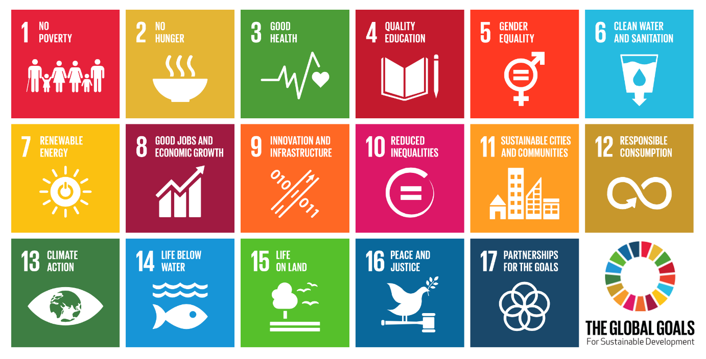

Download the app if you can. Otherwise you can find the goals here: http://www.un.org/sustainabledevelopment/sustainable-development-goals/

50. What is ecotourism? (page 291)

51. How are governments using ecotourism to protect the environment and generate jobs?

Model 1: Weber’s Least Cost Theory

Person who developed the model/theory: (short bio)

Premise: (What is the model supposed to explain?)

Function: (How or when is the model/theory used?)

Illustration: (Draw the model or symbols to demonstrate the key ideas)

Strengths of the model/theory:

Weaknesses of the model/theory:

Describe the effectiveness in the field (past and present)

Model 2: Rostow’s Stages of Economic Growth

Person who developed the model/theory: (short bio)

Premise: (What is the model supposed to explain?)

Function: (How or when is the model/theory used?)

Illustration: (Draw the model or symbols to demonstrate the key ideas)

Strengths of the model/theory:

Weaknesses of the model/theory:

Describe the effectiveness in the field (past and present)

Model 3: Wallerstein’s World Systems Theory

Person who developed the model/theory: (short bio)

Premise: (What is the model supposed to explain?)

Function: (How or when is the model/theory used?)

Illustration: (Draw the model or symbols to demonstrate the key ideas)

Strengths of the model/theory:

Weaknesses of the model/theory:

Describe the effectiveness in the field (past and present)

